To Whom It May Concern,

Street Trendz began doing business as an automotive customization and detailing shop. It quickly earned the reputation for being an industry leader in both quality of craftsmanship and innovation of installations. In October of 2011, Street Trendz made a push to expand into the market of pre-owned vehicle sales. The company moved to a new location, 6322 Kingsway, in May of 2012. Prior to Street Trendz occupying this location, it could be said that the building wasn’t in the best condition and considered an “eye-sore” in this community. Despite not owning this property, Street Trendz has invested its own capital to refurbish this building both inside and out. Currently, the building’s condition reflects the fact that Street Trendz feels obligated and has taken action to create an overall better image of the neighbourhood it calls home. Street Trendz also helps members of its community by offering financing to individuals who are struggling financially or those who have been denied at the bank. Furthermore, Street Trendz feels strongly that by helping people achieve vehicle ownership through financing, they are able to not only seek and maintain better employment, but to also spend more time with their families and children. Clients who have taken advantage of the aforementioned financing have praised the company for offering them non-predatory repayment terms, in most cases, with little or no interest at all.

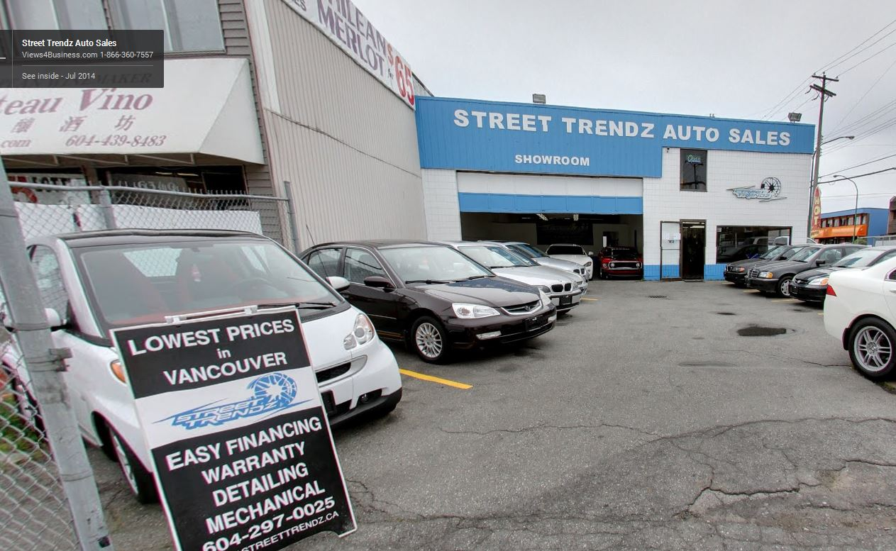

*May 2012 June 2014*

Up until August 2, 2012, Street Trendz had two owners and directors. The owners were Rosa Aiello and Maxwell MacLean. The division of company duties was structured very simply; Maxwell MacLean was primarily responsible for one main company function, the purchase and reselling of vehicles. Rosa Aiello was primarily responsible for the company’s finances, and other paperwork including keeping the company up to date with tax return filings. However, due to personal reasons and the fact that the company was struggling financially, Rosa Aiello left Street Trendz and transferred all of her shares of the company to Maxwell MacLean. This left Maxwell MacLean responsible for all aspects of the company, including filing tax returns. Up until this date, Street Trendz had always filed its tax returns on time and paid immediately. Being overwhelmed by the day to day company operations, Street Trendz did not file returns shortly after this period. There is a multitude of reasons for the non-filing of returns, including but not limited to;

1. Lack of knowledge about how to file a PST, GST, or corporate tax return.
2. Inability to find accurate and simplified information on how to file returns.
3. Financial inability to hire an accountant to file returns.
4. Confusion regarding the different types of returns a company must file.
5. Inability and lack of knowledge regarding employee deductions and those remittances.
6. Financial hardships for both the company and its owner, and the personal stress associated with such hardships.
7. Extended lack of correspondence from both Canada Revenue Agency and The Ministry of Finance.

It was not until early 2014 when letters from both Canada Revenue Agency and The Ministry of Finance began to flood the mailbox of Street Trendz. The letters began as a request to file, and very quickly turned into assumed amounts of taxes collected at far exaggerated levels, those levels being also loaded with penalties and interest. The amount said to be owed to both agencies was almost unbearable to look at. However, realizing the severity of the situation, Maxwell began to learn and aggressively seek advice about how to maintain the company’s accounting and tax issues. Maxwell began correcting past accounting errors, and learning the complex matrix of corporate taxes, all the while struggling to keep the company alive. The company’s past errors of not filing returns properly led to a payroll audit conducted by Canada Revenue Agency on May 10, 2014. Without any exaggeration, people have committed suicide because of the stress levels involved with being the subject of an audit. It took less than an hour for the account examiner to realize and understand why the company had not filed returns. The following is an accurate summary of that conversation.

**Examiner:** “Ok, what has happened here?”

**Maxwell:**  “Honestly, I don’t even know how to properly file a return. I’m a small business owner; I used to have a partner who would deal with our taxes. I thought I would have been mailed the papers to fill out, then all of a sudden I was sent all these massive tax bills, I don’t know what to do. This all just happened all of a sudden, and it became overwhelming.”

**Examiner:** “Look, I’m not here to just examine your books, but I’m also here to educate. You can call me anytime you have a question about GST filing or employee remittances. Let’s get these 6 returns filed and I’ll be on my way.”

The examiner then provided all the correct links, sources of information, direction how to, and the expectations regarding GST returns, appropriate tax credits, and filing and remitting for employees. Street Trendz found it to be quite easy to deal with Canada Revenue Agency and believes that Canada Revenue Agency does follow the Taxpayer Fairness and Service Code. The company understands its tax obligation and the purpose of this letter is not to be alleviated of any outstanding taxes. The purpose of this letter is to outline Street Trendz’s version of events surrounding an ongoing issue and being treated voraciously by The Ministry of Finance.

During the same time period mentioned above, The Ministry of Finance was becoming extremely aggressive. Aggressive to the point of representative and collection officer Ashley Tapping, making threatening remarks. Remarks such as “*we can take any amount we feel like.”* “*You better just pay the amount we say you owe, or this will get worse.”* When questioned about the inflated amounts or how The Ministry of Finance generated such a figure, her reply was. *“That’s what happens, you’ll pay what we say you owe.”* It was not until April 22, 2014 that The Ministry of Finance placed a hold on the company’s TD Canada Trust Bank account. The Ministry of Finance did this without any warning, without giving notice and seized $4,595.96 in the process. A record of the seizure amount of $4,595.96 by The Ministry of Finance has not been given by them or TD Canada Trust, despite extensive efforts by Street Trendz to obtain one. The only record of this amount being seized can been seen on Street Trendz’s bank statement for April 2014, of which it shows the money being taken out of the company’s account as a legal demand payment. Furthermore, those monies have not been applied to the outstanding taxes that Street Trendz owes The Ministry of Finance. Without an accurate record or any form of receipt, The Ministry of Finance continues to act obtuse and will not acknowledge that they did in fact receive, through seizure, $4595.96. Street Trendz has been working tirelessly to solve its tax issues and stay up to date with all aspects of corporate tax returns and remittances. Even contacting The Ministry of Finance was a daunting task to say the least, as their behaviour in such issues can only be described as predatory. Through a large number of telephone and email correspondence, a payment arrangement was finally achieved. There were only three conditions of the payment arrangement;

1. An immediate payment of $5800
2. Stay current and up to date with all future remittances.
3. Pay $3,793.91 for 4 months as repayment of debt owing.

The payment arrangement was made VIA a telephone call with The Ministry of Finance’s collection officer Ashley Tapping. When asked about the seizure of $4595.96, there was a short chuckle, before she gave verbal assurances that it would be credited to the company’s PST account. **No credit has been made to date**. Street Trendz honoured their side of the payment arrangement fully, as can be seen on a printout of its eTaxBC account. It can be clearly seen on this printout that PST returns for March, April, May, 2014 were filed on time. The Ministry of Finance was ruthless and predatory in their creation of this payment arrangement, which was structured for Street Trendz to fail by default. In an attempt to honour the arrangement and keep current with PST filing, Street Trendz filed its April return on time; however, the payment sent for this return was not applied. Instead, the payment for the April 2014 PST return was applied to the total amount outstanding. To reroute the payment for current returns to the balance owing made the creation of a payment arrangement utterly redundant.

Street Trendz, having been working hard to stay current, did not realize what was about to happen next. The company had not expected The Ministry of Finance to act so high-handed with an insatiable appetite for its capital and gaining a disturbing delectation in watching a small business and community leader suffer and fail.

Street Trendz had not noticed that the payment for its April 2014 had been applied to the total balance owing, and not credited to the April 2014 PST return. This resulted in a second hold being placed on Street Trendz’s TD Canada Trust account; this was done maliciously, and without warning. As a result, all direct payments Street Trendz pay’s various suppliers was returned NSF. Many attempts to contact Ashley Tapping, The Ministry of Finance, or a regulatory body went unsuccessful. Having felt to be the victim of financial persecution, Street Trendz has not filed a return for June or July 2014. The company is acting accordingly considering The Ministry of Finance not only dishonoured their end of the payment arrangement, but had structured it for Street Trendz to intentionally fail.

On August 13, 2014, Senior Court Bailiff Dan Iannacone arrived at the premises of 6322 Kingsway. An employee of Street Trendz was presented with a writ of seizure and sale. Documents were also presented showing an inflated PST bill of $18,410.49. Dan Iannacone acted inappropriately, careless, and with unlawful force. During his duties as a bailiff, when he was questioned about his intent and the extent thereof, his answer was simply, “*you* *ask too many questions*.” He acted as if he was above the laws of Canada and British Columbia. He abused his power, and furthermore, he is not listed on the Province of British Columbia’s own website as being authorized to perform a writ of seizure and sale. There were three vehicles seized on August 13, 2014;

1. 2008 Nissan 350z Grand Touring (Rebuilt) – 39,000 miles $17,550
   1. DVD & Navigation $ 400

**TOTAL $17,950**

1. 2009 Kawasaki KLR 650 – 22,000 km’s $3,500_

**TOTAL $3,500**

1. 2004 Chevrolet Trailblazer – 177,000 km’s $4,925
   1. 5.3L V8 Vortec Engine $ 275__

**TOTAL $5,200**

**GRAND TOTAL OF ITEMS SEIZED (WHOLESALE VALUE) $26,650**

**GRAND TOTAL OF ITEMS SEIZED (RETAIL VALUE) $29,764**

All values stated above come directly from ICBC’s Gold Book, all values have also been reduced to a wholesale value. Retail sales of the above vehicles would substantially increase the revenue from such sales.

Immediately after the aforementioned seizure, Street Trendz sent a warning letter to both The Ministry of Finance and Dan Iannacone advising them that if the above vehicles are sold at less than the wholesale values, that they would be doing so at their own loss. The value of the vehicles seized far exceeds the debt owed to The Ministry of Finance. The difference of which Street Trendz is legally entitled to charge penalties and interest, in the exact amounts applied to Street Trendz by The Ministry of Finance. Any refusal of the application of such penalties and interest charges would in fact imply that we live in an unjust society, a society where government agencies may fabricate any debt amount they wish, dishonour agreements, seize items without a basis for valuing those items, and selling those items without repercussions.

Here is a breakdown of the excessive application of interest, penalties, disallowed tax commissions, and other unnecessary hardships that have been applied to Street Trendz by The Ministry of Finance or its representatives.

**AMOUNT** **TOTAL**

April 22, 2014 – Money seized from TD Canada Trust bank account. $4,569.10 -$4,569.10

*This money still has not been credited to PST amount owing*

April 24, 2014 – Letter received outlining debt owed to Ministry of Finance. $20,802.25 $16,233.15

April 24, 2014 – Money seized from TD Canada Trust bank account. $26.86 $16,206.29

*This money still has not been credited to PST amount owing*

April 28, 2014 – Down payment as per payment arrangement. $2,888.87 $13,317.42

$2,911.13 $10,406.29

April 30, 2014 – April 2014 PST return filed. $2,390.16 $12,796.45

June 14, 2014 – May 2014 PST return filed. $1,656.29 $14,452.74

June 16, 2014 – Money seized from TD Canada Trust bank account. $383.04 $14,069.70

June 18, 2014 – Money seized from TD Canada Trust bank account. $24.05 $14,045.65

August 13, 2014 – June 2014 PST return filed. $2,615.25 $15,850.90

August 13, 2014 – July 2014 PST return filed. $4,454.07 $20,304.97

August 13, 2014 – Total NSF fees from TD Canada Trust bank account seizure. $810.00 $19,494.97

August 13, 2014 – Total disallowed tax commissions. $2,185.99 $17,308.98

August 13, 2014 – Total penalties applied. $3,634.76 $13,674.22

August 13, 2014 – Total interest applied . $821.24 $12,852.98

August 13, 2014 – Total value of 3 vehicles seized. $26,650 -$13,797.02

August 14, 2014 – Money Owed to Street Trendz by the Ministry of Finance. **$13,797.02**

As you can see, the total amount of monies taken from Street Trendz and applied to its PST bill, is far less than what has been taken from Street Trendz. There is no excuse for this kind of brute action from The Ministry of Finance, or its representatives, specifically Ashley Tapping. Her actions have shown that she is unable to act responsibly or ethically. She uses her position to abuse small businesses in the Province of British Columbia and should be terminated from The Ministry of Finance’s employ effective immediately.

As mentioned in the first paragraph of this letter, Street Trendz has and continues to help members of its community. Street Trendz has taken actions and continues to strive to make Burnaby, the Province of British Columbia, and Canada a better place. The company’s business principals of lower vehicle prices for everybody, no hidden fees, reliable and honest service, and available financing for underprivileged families, is a good model to strengthen its community and economy.

As Street Trendz has helped its neighbourhood, it now needs your help. If you are receiving this, then Street Trendz feels that you are, can be, or can do one of the following, and humbly requests your assistance.

1. An advocate of justice on the company’s behalf.
2. Believe in government accountability.
3. Can talk to The Ministry of Finance on our behalf, as our attempts have been unsuccessful.
4. Demand that Street Trendz be treated within the guidelines set forth in the Taxpayers Fairness and Service Code.
5. Street Trendz feels you are interested in this information.

Or

1. You have been a direct part of vexing Street Trendz and its employees
2. You have abused your powers and should be ashamed.
3. You have acted malicious, unjust, and ignominious regarding your dealings with Street Trendz.

Street Trendz is requesting your help with the following issues;

1. Alleviate Street Trendz from the penalties and interest applied to its PST debt.
2. To be given credit for $4,595.96 that has been seized and not credited to Street Trendz’s PST debt.
3. The removal of a legal demand payment on the companies TD Canada Trust bank account, which has resulted in Street Trendz being unable to accept any form of payment besides cash. Street Trendz wishes to conduct business normally, and without persecution from the Ministry of Finance.
4. To be given fair value applied to the 3 vehicles seized on August 13, 2014.
5. Allow Street Trendz to claim commissions for all past PST returns.
6. The immediate termination of Ashley Tapping from The Ministry of Finance’s employment.
7. The immediate payment of **$13,797.02** from The Ministry of Finance to Street Trendz, as per the accurate calculations outlined above.
8. A letter of apology written by the honourable Michael de Jong himself, or a letter explaining why small business should fail, and outline the role the Ministry of Finance plays in such a beneficial failure, also written by the honourable Michael de Jong.

Please help Street Trendz and its employees in this time of need. Attached to this letter are some supporting documents. Please do not hesitate to request further documentation of aforementioned events, make further inquiries, or contact Street Trendz directly if you feel that you can help.

Respectfully,



**Maxwell MacLean**

Owner & Sales Manager

Street Trendz Auto Sales

*References*

British Columbia Provincial Sales Tax Act

<http://www.bclaws.ca/civix/document/id/complete/statreg/12035_00>

Taxpayer Fairness and Service Code

<https://www.sbr.gov.bc.ca/msbr/tfsc/booklets.htm>

Current authorized bailiff directory

<http://www.ag.gov.bc.ca/courts/other/bailiff/index.htm>

